Proficiency Gold (for the revised CPE Exam) BOOK + AUDIO + TEACHER'S BOOK
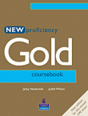

Author: Jaqueline Newbrook, Judith Wilson
Publisher: Longman
New Proficiency Gold corresponds to the most recent specifications of the Cambridge Proficiency exam. The course provides enjoyable and thorough preparation.
- Special Exam Focus sections for each paper and new text-based activities for Paper 1, part 1, and Paper 3, parts 1 and 2
- Regular opportunities for reviewing and testing, with additional photocopiable tests in the Teacher’s Book
- Emphasis on personalisation gets students involved and interacting in class
- Smart, contemporary look and enjoyable texts have instant appeal

CPE Use of English Examination Practice (Student's book + Teacher's book)

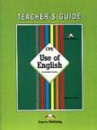
Author: virginia evans
Publisher: Express Publishing
Key features
- condensed presentation of grammar structures followed by graded exercises on each structure
- consolidation units consisting of:
- cloze passages
- phrasal verbs
- idioms
- prepositions
- sentence completion exercises
- transformation exercises
- rephrasing exercises
- proof reading exercises
- word usage
- collocations
- practice tests helping students through the Cambridge Proficiency Examination.
- Appendices on phrasal verbs, idioms, prepositions and verbal constructions.
The book is accompanied by a Teacher's Guide containing the answers to the exercises as well as notes on the word usage.

CPE Practice Tests 2 (Student's + Teacher's book)

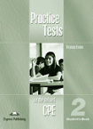

Author: Bob Obee, Virginia Evans
Publisher : Express Publishing
Cambridge Proficiency Examination Practice Tests 2 is a set of six complete practice tests written in line with the specifications for the revised Cambridge Proficiency Examination (introduction December 2002). This set of tests, written by an experienced EFL author, provides comprehensive coverage of the type of language points and individual skills focuses targeted in the examination.

FCE Masterclass 2004 (Student's Book + Audio CDs)

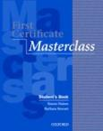
Author: Simon Haines and Barbara Stewart
Publisher: Oxford University Press
The course prepares students for the FCE by providing exam-style procedures. The reliability of this well-known title has been combined with new material and a fresh look.
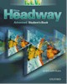
  Title: | New Headway Advanced Student's Book

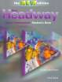
  Title: | New Headway Upper Intermediate Student's Book THIRD Edition

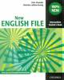
  Title: | New English File Intermediate Student's Book

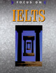
  Title: | Focus on IELTS Student's Book

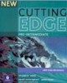
  Title: | New Cutting Edge Pre-intermediate Student's Book

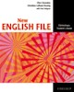
  Title: | New English File Elementary Student's Book

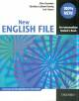
  Title: | New English File Pre-intemediate Student's Book

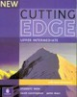
  Title: | New Cutting Edge Upper Intermediate Student's Book

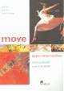
  Title: | Move Upper Intermediate Student's Book + FREE CD-Rom

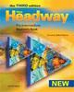
  Title: | New Headway Pre-intermediate Student's Book THIRD Edition

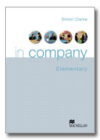
  Title: | In Company Elementary Student's Book + CD-Rom

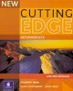
  Title: | New Cutting Edge Intermediate Student's Book

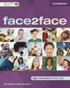
  Title: | Face2Face Upper-intermediate Student's Book + CD-Rom

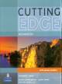
  Title: | Cutting Edge Advanced Student's Book

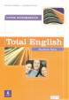
  Position: | 15
  Title: | Total English Upper Intermediate Student's Book
  ISBN: | 9780582846326
  Price: | £17.90

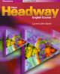
  Position: | 16
  Title: | New Headway Elementary Student's Book
  ISBN: | 9780194366779
  Price: | £18.00

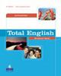
  Position: | 17
  Title: | Total English Advanced Student's Book
  ISBN: | 9780582841710
  Price: | £17.70

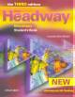
  Position: | 18
  Title: | New Headway Elementary Student's Book THIRD Edition
  ISBN: | 9780194715096
  Price: | £18.00

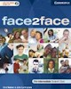
  Position: | 19
  Title: | Face2Face Pre-intermediate Student's Book + CD-Rom
  ISBN: | 9780521603355
  Price: | £17.70

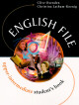
  Position: | 20
  Title: | English File Upper Intermediate Student's Book
  ISBN: | 9780194368629
  Price: | £18.50

